ROLE OF SOCIAL MEDIA IN FILM PROMOTION IN INDIA
Aarushi Raina - aarushi.raina2010@gmail.com
Vinny Ahuja - vinnyahuja29@gmail.com
ABSTRACT
The purpose of the study was to know the role of social media in film promotion. Film promotion is one amongst the foremost necessary part of film making. Now days facebook, YouTube , twitter etc are main social media platform for the promotion of films. As social media became an important part of daily life of the many. Social media has the ability to create buzz among fans, new media is the latest addition to the present arena. Film has conjointly started utilizing the potential of social media completely in terms of marketing and promotion. The Indian film industry is not left far behind. It is using new media as well as social media forum to make people aware of the film and to drive them towards theaters. This study is done in area of social media users and how they are leaned in films
To get on the main purpose of the research , the primary data was collected through survey. A quantitative research approach is used as a research instrument in this study. To explore and know more gone through various research papers and The study shows that social media plays a vital role in film promotion in India . Approximately, 85% of people believe that social media is a great way of promoting the release of new movie. Now days social media becoming way to decide whether the film will be a hit or a flop at box office. Through the finding it has been proved that the success of the film not only depend on the factors like story , script and star cast but also depends on the promotion .social media becomes a very cheap way of promoting and reviewing movies and people love to follow it and find it easy
Keywords – Social media, Film promotion, Facebook and YouTube.
INTRODUCTION
With the introduction of social media into every field of our daily life, cinema and film industry together has become medium that gets benefits from social media. Like other sectors, film industry also has embraced the potential of social media for its promotions and marketing. Although, marketing has always been engulfed with various dark shades, it is currently considered as vital because of the actual creating of the product. With the rapid development of technology, industry is becoming more established by using varied phases like music launch, promotional tours, trailer launch etc. as its mark mediums. While social networking sites like Facebook and Twitter are becoming necessary a part of many life, so how film industry can stay behind in not using these sites to achieve benefit.
The social networks are the foremost happening places these days and also the stars within the Film industry have started using them as a promotional tool for their films.
Social media has become a platform where different people gather online to share various types of news, information and opinions through conversations. It is turning out to be a predominating trend for today’s generation where everyone can connect to other people anywhere around the world just by talking to them through social media websites in the form of mails, chats; etc. Social media is playing a crucial role in business ,as many business entities today are using social media as a platform to promote their business and raise it to a higher level. The film industry has been greatly affected by the rise of this trend. The movies are now mostly available for online viewing. Now days, social media has been looked and taken into consideration by filmmakers to promote their films, connect with audience and fans. This research describes the rapid development of social media and how it is used for promotion of films. This research concludes the further development and future of social media.
When discussed about films in relation with social media it is found that social media users comments online about films they see, according to one poll. People often create certain thinking or an image of a movie after reading the reviews or comments of other people for specific movies & at the end they keep certain expectations from the movie of being good or an average movie before watching it. Now days audience immediately share their opinions on a massive scale through social media , that means a film’s fate is likely to be decided faster and then amplified. Also by this act the social media divides the winners from the losers more quickly. As a result of this the weaker films will die much more quickly that means it will have a lesser amount of audience as well as a low box office collection, and the successful films will be much more successful in comparison where they will be hitting the box office collection at heights. Films targeting over older viewers, who remain influenced by the critics review, often slip through the social media web & have a smaller opening weekends but have more stable box office figures in the upcoming weeks.

OBJECTIVES

To know the role of social media in film promotion and understand the dependency of people on social media for the reviews of films

HYPOTHESIS
Social Media do not play a significant role in film promotion.

REVIEW OF LITURATURE
According to Kerynne Tejada (2015), titled “Social Media Marketing in the Film Industry” , in his relevant research paper said Movies are a way to portray culture, education, leisure, and propaganda by influencing how one thinks and feels. They are so powerful that they can influence a nation’s wealth and outlook. He also said that people would not have been aware of a movie exist or not ,if there is no type of promotion for the movies. An entire industry of film promotion was made for people to know about current and upcoming movies.
As the nation has developed ,thus did the Indian film industry. Promotion and promotional activities revolve around the movie as witnesses there is a drastic changes. Earlier when a movie was created the main concern was good distribution system for availability of film to the people. However now days it has taken steps ahead, the awareness and promotion are essential key for success.
DIGITAL MEDIA
With the introduction of digital technology, the filmmakers are able to promote their movie in new form. Earlier the filmmaker use to get their poster published in newspaper so that people come to know about the movie but by going digital, filmmakers make their posters, teasers/trailers more entertaining and to aware the audience about their upcoming.
In the age of instant communication, how social media can be left behind when it comes about film promotion. Social media has many platforms but popular ones are Facebook , Twitter and YouTube on which films are promoted .

Happy New Year
Year-2014
Director – Faraha Khan
In this movie Faraha Khan and Shah Rukh Khan used social media fully to promote their film .As the film was already was in news because of the star cast but they didn’t miss any opportunity to promote their film..Actors through their official twitter account started promoting movie Happy New Year 2 months before the release date i.e. October . And to create more anxiety among the audience about the movie all the six star cast of the film added their character name from Happy New Year alongside their personal names.

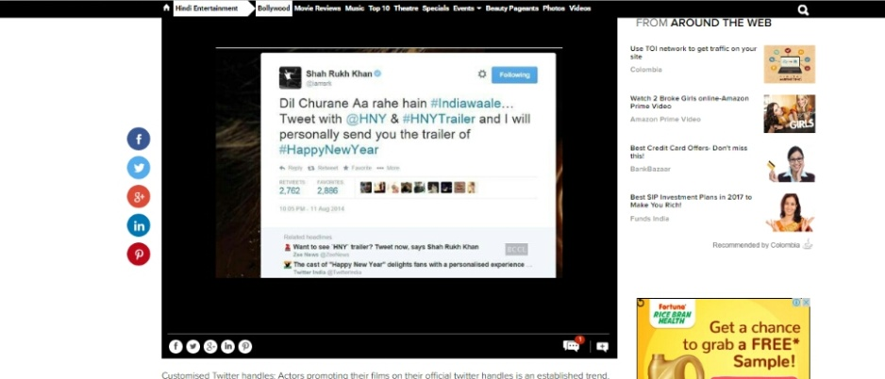
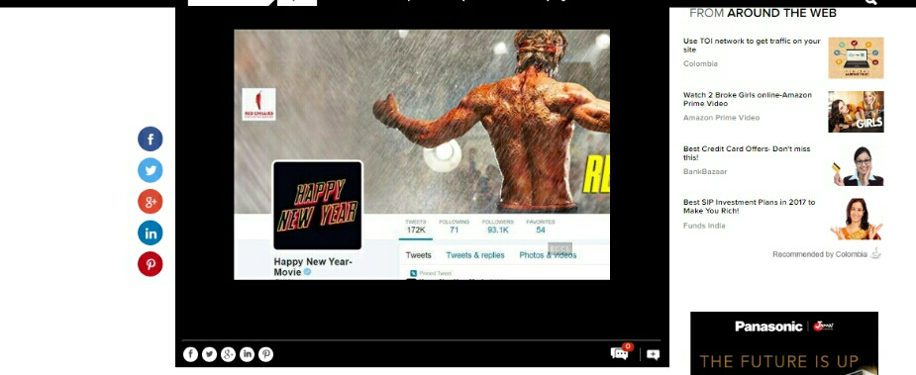
As soon as the movie is released, official movie page is made on Twitter .In which the team constantly updates about the film .Although the movie story was average but still the movie got success because of the constant promotion on social media platforms by the team of HNY.
BAAHUBALI
Year-2015
Director- S.S Rajamouli
The filmmaker of this film used social media in different way. His first post related to the movie was on Facebook where he uploaded the link about the online auditions for casting which created flood of 5000 applications for makers. This was the unique way to create curiosity among the audience about the move.
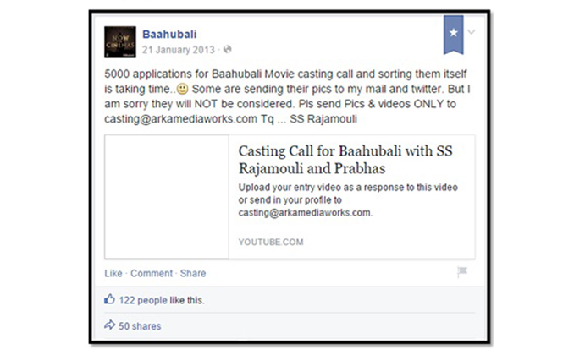
Like other film makers, Rajamouli didn’t stick to one platform, next he came with his launch of movie trailer by using the power of hashtag on Twitter. There was not too much of gap between the trailer it was just one month before the release date of the movie,
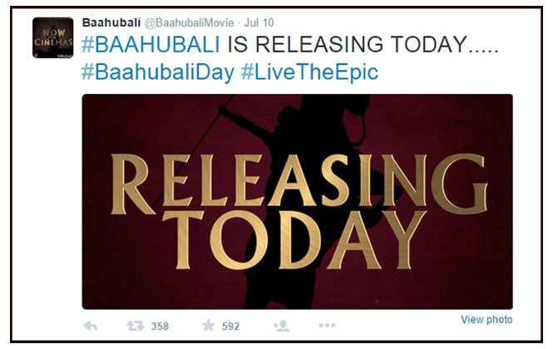

After all the promotion strategies on different platforms of social media Baahubali movie was a success at box office but it was not enough the movie team wanted to make at most of it so they launched quizzes related to film and video games . With their smart post release tactics they engaged the audience towards their film.
RESEARCH METHODOLOGY
The central aim of the research was summarized into set of research questions. Through quantitative method i.e. survey, the primary data was collected. The quantitative content analysis has been chosen as a suitable method to explore about different social media platforms for film promotions. As content analysis is usually applied to review the film, newspaper, digital media, radio etc and also provide knowledge and new insight to the facts. For this purpose the film promotion most used social networking sites like facebook and twitter accounts were taken under consideration. For sampling the data, the simple random sampling method was used.
To review the role of social media in film promotion, questionnaire as a tool of research is used. Closed ended questions were prepared for questionnaire. As the objective of this research is expressed by the following questions ; Do you think that the social media is a way of promoting the new movie releases? , Is social media turning out to be a way to decide whether the films will be a hit or a flop at the box office? , Do you believe the posts or updates given on Facebook & Twitter about the movies helps to decide whether to go for it or not?.
To know and explore fully about the topic, secondary data was taken under consideration by going through various research papers .
RESEARCH FINDINGS
The data was collected of 105 respondents and it is combined in the form of pie chart of each question separately to clearly see the response and understand it easily for all questions.
Gender =105 | Male=60 | Female=45
Q1=102 | Comedy = 69 | Horor=35 | Social awareness  based=49 | Action=40 | Thriller =31 | Others =7
Q2=104 | Very often=35 | Often= 37 | Rarely= 21 | Never=0 | Sometimes=11
Q3=104 | 1-5=84 | 5-10=14 | More than 10  =1 | None= 5
Q4=100 | Facebook  =92 | Twitter=46 | YouTube=43 | Instagram=80 | Snapchat=66 | Blogger.com=14
Q5=104 | Yes=88 | No=4 | Maybe=12
Q6=104 | Yes=66 | No=26 | Don’t know=12
Q7=102 | Yes=57 | No=7 | Sometimes=38
Q8=104 | Yes=30 | No=38 | Maybe=25 | At times=11
Q9=104 | Yes=37 | No=38 | Maybe=29
Q10=101 | Yes=79 | No=22
Q11=103 | Yes=55 | No=19 | Maybe=29
Q12=103 | Yes=57 | No=30 | Maybe=16
Q13=104 | Yes=52 | No=21 | Not sure=21 | Maybe=10
Q14=104 | Good=39 | Bad=2 | Neutral=30 | Depends=33
Q15=104 | Yes=51 | No=15 | Maybe=29 | Don’t know=9

Q1 What kind of movies do you prefer to watch?

According to data collected 98% of respondents watch films in different categories but most preferable is comedy movies and social awareness based .
Q2 How often do you visit theaters?

The above data shows that 29%of respondents often watch film in theaters and there is no one who never watched movies in theater.

Q3 How many social networking sites you are a member of?

Collected data shows that 80% of people use 1 to 5 social media platforms or member of those social media sights and only 5% doesn’t use social media

Q4 On which social network you have created a personal profile (You can choose more than one).

The most used social media platform is facebook by 33% of respondents and lowest is blogger.com by 5 %
Q5 Do you think that the social media is a way of promoting the new movie releases?
85% of people thinks that the social media is a way of promoting the new movie releases and 4 % is not sure about it

Q6 Is social media turning out to be a way to decide whether the films will be a hit or a flop at the box office?

64% of respondent says that social media turning out to be a way to decide whether the films will be a hit or a flop at the box office and rest dont agree to or not sure

Q7 Do you believe the posts or updates given on Facebook & Twitter about the movies helps to decide whether to go for it or not?

56% believes that the posts or updates given on Facebook & Twitter about the movies helps to decide whether to go for it or no and rest disagree or not sure about it

Q8 Would you rate the movies according to the reviews given on different websites after its release?

According to the above data shows that 36% of respondents don’t rate the movie based on the reviews given on different websites ,where there are 29% of respondents who rate the movie after watching the reviews on different websites.
Q9 Do you think a film’s success shall be credited to social media?

The above data collected shows that 37% respondents don’t believe that film success shall be credited to social media ,while 35% of respondents believe that the film success should be based on social and there were 28% respondents didn’t know that it should be credited or not to social media.

Q10 Do you want to see film promotion on social media?

The above data show that 78% respondents want to see film promotion on social media, where there were 22% of respondents don’t want to see film promotion on social media.
Q11 Are Hollywood movies promotion on social media is more preferable over the Bollywood movies promotions?

According to the data 53% of respondents prefer Hollywood movies promotion on social media more than the Bollywood movies promotion. While there were 28% of respondents believe that Bollywood movies promotions on social media are more preferred than Hollywood movies promotion.
Q12 Do you feel that the film productions, its promotions & distribution cannot be done without social media platform?

The above date shows that 55% of respondents feel that the film productions, its promotions & distribution cannot be done without social media platform, where there were 16% respondents were not sure.
Q13 Social media is the only source that helps you to built up the contacts & follow the people of this entertainment industry like the directors, producers, actors; etc. Agree?

According to the data 50% of respondents think that social media helps to built up the contact and follow the people of entertainment industry, where 10% of respondents are not sure.
Q14 According to you is social media good or bad for the film industry?

According to the data 37% of respondents consider social media good for film industry ,while 2% of respondents consider social media to be bad for film industry.
Q15 Is the film industry's business getting affected because of social networking sites presence?
The above date shows that 49% of respondents believe that business of film industry is getting affected due to presence of social networking sites .While 9% of respondents don’t know whether the business of film industry getting affected due to presence of social networking sites or not.
CONCLUSION
The purpose of the study was to know the role of social media in film promotion. To explore and review the medium of film promotion, quantitative content analysis method was used. The popular medium used by the film makers are Facebook, twitter and Youtube as we came across in this study. The study shows that social media plays a vital role in film promotion in India. Approximately 85% of people thinks that social media is a great way of promoting the release of new movie. Now day social media turning out to be a way to decide whether the film will be a hit or a flop at box office like example of movie Happy New Year the story was average but because of so much promotion on different social media platforms the movie became a hit. These days audience instantly share their views regarding films on social media, the review on social networking sites somehow affect the audience to decide whether to go for a movie or not . Earlier film promotion was done through newspaper and television commercials but now social media become a new way to promote a film which also helps in getting feedbacks from people. By using the popular social media platforms the filmmakers or actors create curiosity among the audience 2 to 3 months prior the release of the movie like Baahubali filmmaker Rajamouli started his film promotion by posting online casting auditions which was smartly done to grab the audience attention from the beginning of e promotion of the movie which made this strategy a success as 122 people liked the post and 50 people shared it .5000 applications were send by the people for getting casted in the film. The social media platform was fruitful for the movie Baahubali as all the promotional strategies were able to grab the attention of the audience towards the movie and forced them to go to theatres to watch the movie. In both the movies promotion Happy new year and Baahubali ,social media played a vital role .The data collected which also showed that 35% of people believe that the film success should be credited to social media
Through the above finding it has also been proved that ,now days the success of the film does not only depend on the factors like story line, script and star cast but also depends on the promotion.
Hence, the hypothesis described earlier in the study has been proved wrong because social media plays a important role in film promotion.
REFRENCES
Tejada, Kerynne (2015) Social Media Marketing in the Film Industry retrieved from http://digitalcommons.calpoly.edu/cgi/viewcontent.cgi?article=1148&context=grcsp
Kuruca, Yasemin (2013), Akyol, Mevlut (2010), Movie Promotion through social media retrieved from https://www.academia.edu/9724538/MOVIE_PROMOTION_THROUGH_SOCIAL_MEDIA
Sedeke, Kristina (2012), Effective Fashion Blogs and Their Impact on the Current Fashion Industry retrieved from https://thesis.eur.nl/pub/12317/Sedeke.pdf

